***OOP LAB TASK # 11***

***Name: Shahmeer khan.***

***ClassID: 106278.***

***Student-ID:12113.***

***Task:***

***Question no. 1:***

***Inputted Code:***

using System;

using System.Collections.Generic;

using System.Linq;

using System.Text;

using System.Threading.Tasks;

namespace Lab_Task

{

class Program

{

static void Main(string[] args)

{

Console.WriteLine("OOP LAB TASK 11:");

Console.WriteLine("Question no. 1:");

Human function = new Human();

function.Total_Distance(10, 12);

Console.ReadKey();

}

}

class Human

{

public void Total_Distance(int Walk, int Run)

{

for (int i = 0; i <= Walk; i++)

{

Console.WriteLine("\nRunning at a speed of " + Run + " km/h.\n Walking.. Steps covered: " + i +

"\n Distance covered: " + Walk + "\n");

}

}

}

}

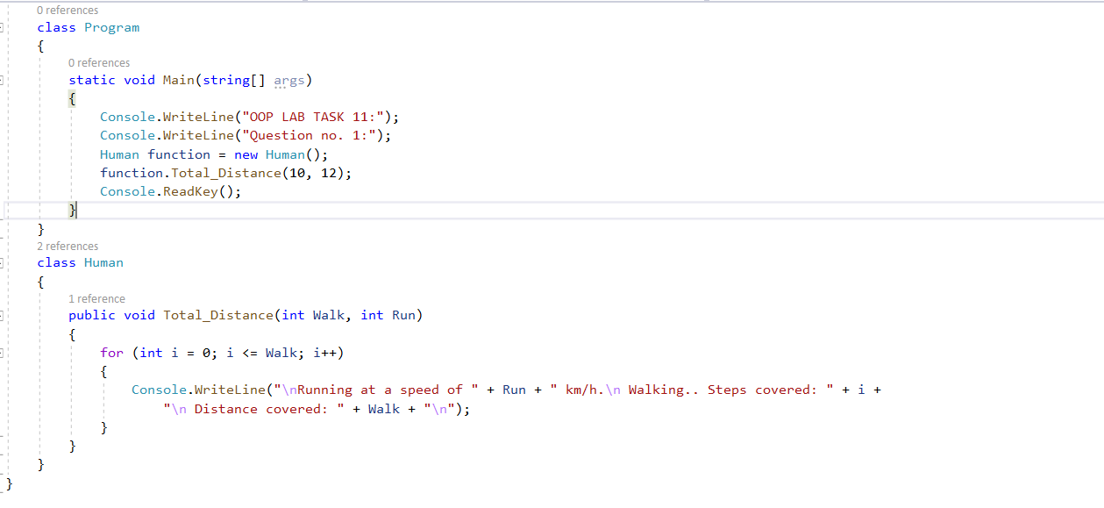

***Output:***

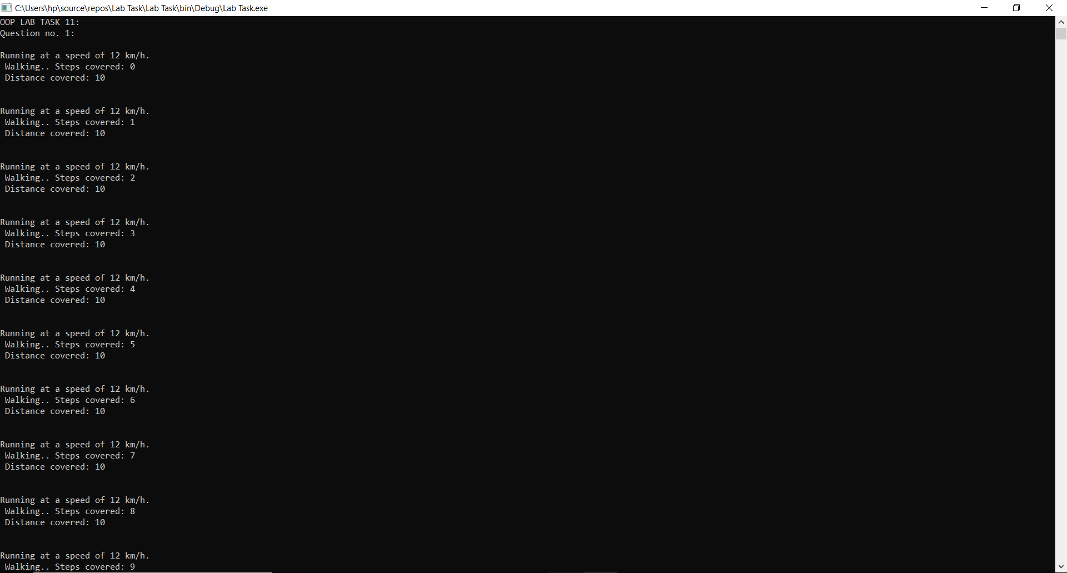

***Question no. 2:***

***Inputted Code:***

using System;

using System.Collections.Generic;

using System.Linq;

using System.Text;

using System.Threading.Tasks;

namespace Lab_Task

{

class Program

{

static void Main(string[] args)

{

Console.WriteLine("OOP LAB TASK 11:");

Console.WriteLine("Question no. 2:");

Console.Write("Enter Starting Point: ");

string Start = Console.ReadLine();

Console.Write("\nEnter Stopping Point: ");

string Stop = Console.ReadLine();

Train obj = new Train();

Console.WriteLine("\nObject 1 used:");

obj.EngineWork(Start, Stop);

string Work;

Work = Start;

Start = Stop;

Stop = Work;

Console.WriteLine("\n-------------------------");

ReverseTrain obj2 = new ReverseTrain();

Console.WriteLine("\nObject 2 used:");

obj2.EngineWork(Start, Stop); //EngineWork method eassily called because of inheritance

Console.ReadKey();

}

}

class Train

{

public void EngineWork(string Source, string Destination)

{

Console.WriteLine("Starting-Point: " + Source);

Console.WriteLine("Ending-Point: " + Destination);

}

}

class ReverseTrain : Train

{

}

}

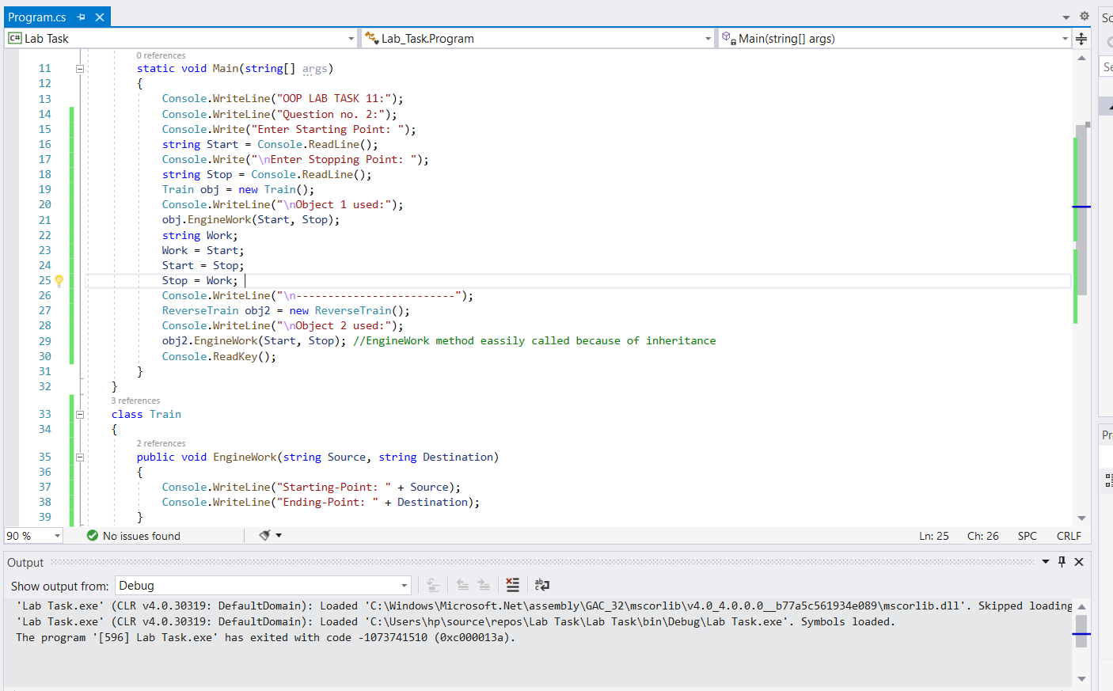

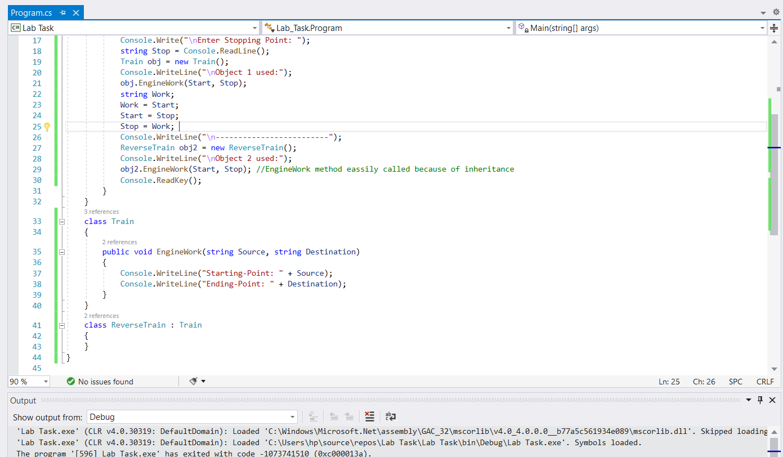

***Output:***

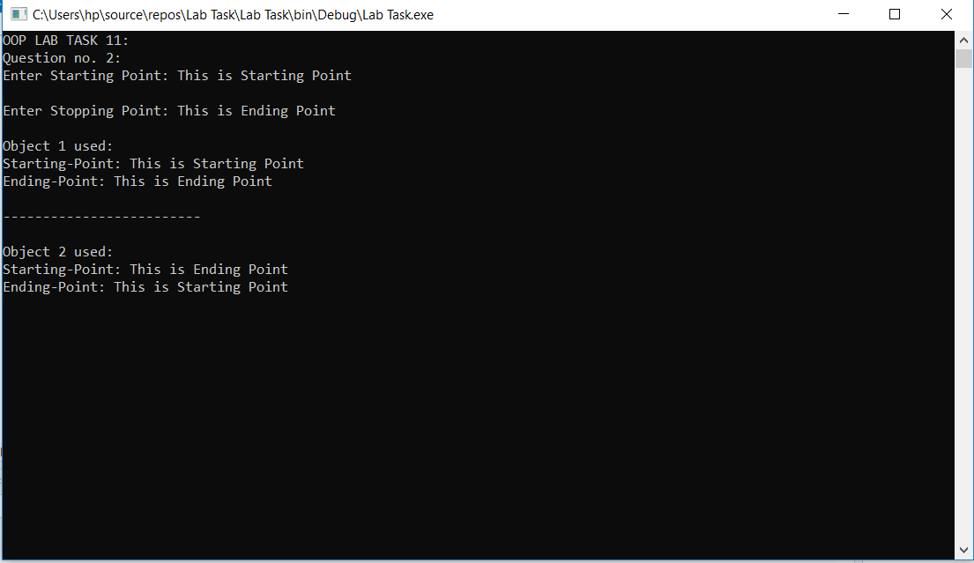

***Question no. 3:***

***Inputted Code:***

using System;

using System.Collections.Generic;

using System.Linq;

using System.Text;

using System.Threading.Tasks;

namespace Lab_Task

{

class Program

{

static void Main(string[] args)

{

Console.WriteLine("OOP LAB TASK 11:");

Console.WriteLine("Question no. 3:");

Console.Write("Enter Starting Point: ");

string Start = Console.ReadLine();

Console.Write("\nEnter Stopping Point: ");

string Stop = Console.ReadLine();

Train obj = new Train();

Console.WriteLine("\nObject 1 used:");

obj.EngineWork(Start, Stop);

Console.WriteLine("\n-------------------------");

ReverseTrain obj2 = new ReverseTrain();

Console.Write("\nEnter journey Time: ");

int JT = int.Parse(Console.ReadLine());

Console.WriteLine("\nObject 2 used:");

obj2.EngineWork(Start, Stop, JT); //EngineWork method eassily called because of inheritance

Console.ReadKey();

}

}

class Train

{

public string Start;

public string End;

public void EngineWork(string Source, string Destination)

{

this.Start = Source;

this.End = Destination;

Console.WriteLine("Starting Point: " + Start);

Console.WriteLine("Ending Point: " + End);

}

}

class ReverseTrain : Train

{

public void EngineWork(string Source, string Destination, int JourneyTime)

{

// base.EngineWork(Source, Destination);

this.Start = Source;

this.End = Destination;

Console.WriteLine("Starting Point: "+ Start);

Console.WriteLine("Ending Point: "+ End);

Console.WriteLine("Total Journey Time: " + JourneyTime + " hrs");

}

}

}

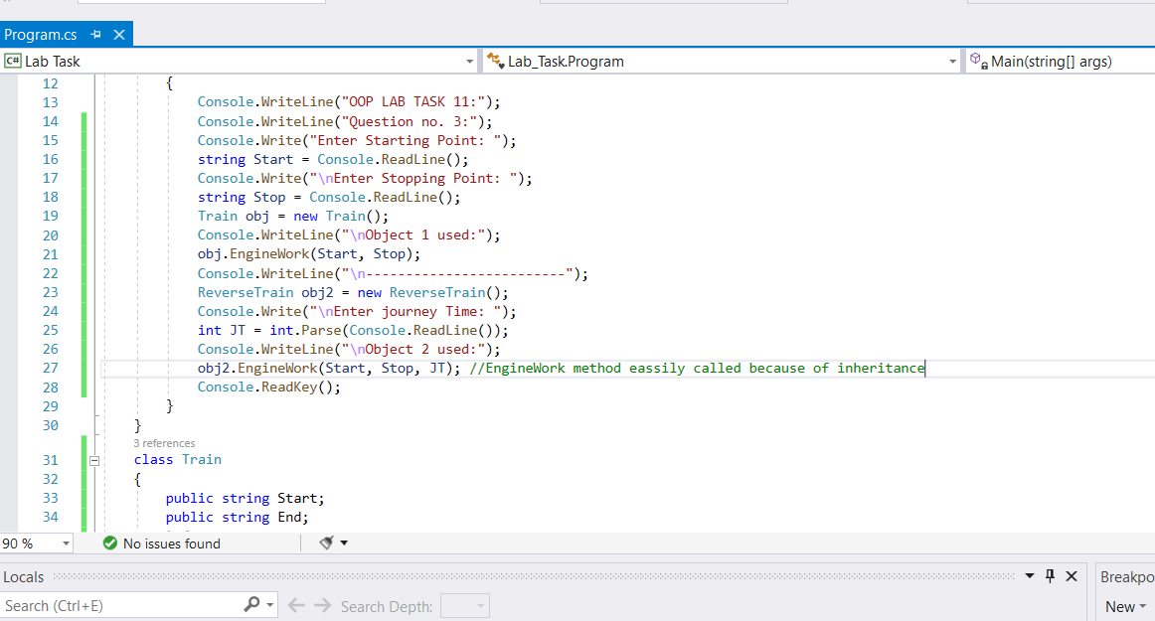

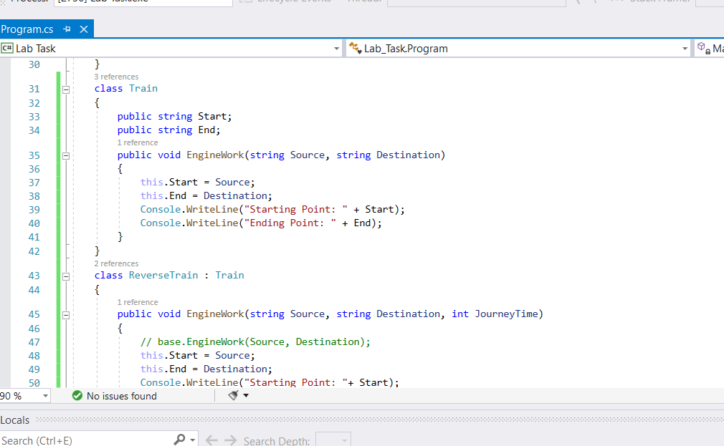

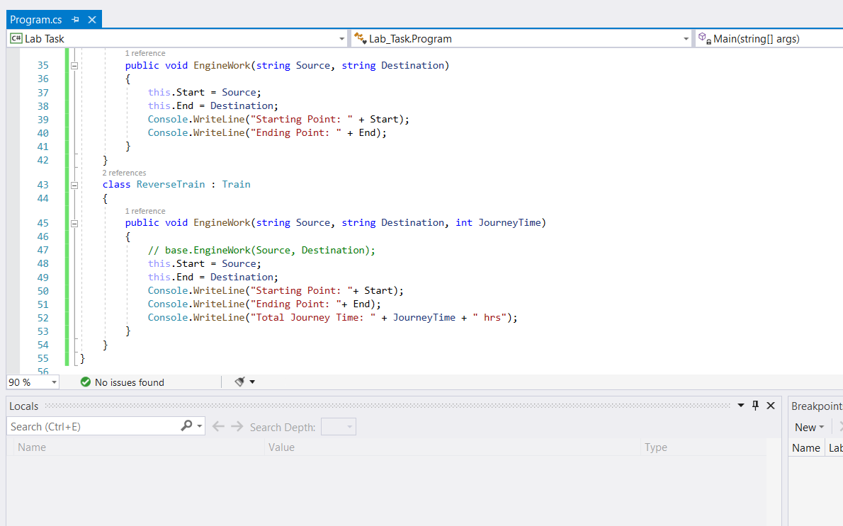

***Output:***

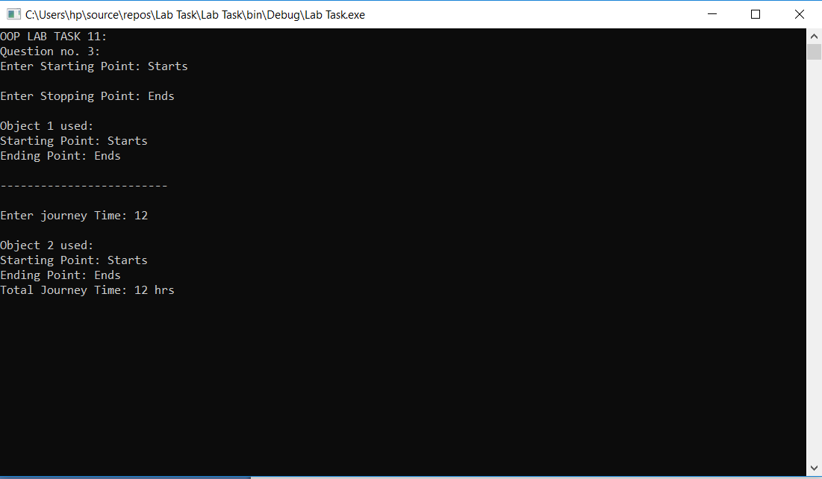

***Question no. 4:***

***Inputted Code:***

using System;

using System.Collections.Generic;

using System.Linq;

using System.Text;

using System.Threading.Tasks;

namespace Lab_Task

{

class Program

{

static void Main(string[] args)

{

Console.WriteLine("OOP LAB TASK 11:");

Console.WriteLine("Question no. 4:");

Console.Write("\nEnter the distance, in Kilometers, covered in Journey A:");

int a = int.Parse(Console.ReadLine());

Console.Write("\nEnter the distance, in Kilometers, covered in Journey B:");

int b = int.Parse(Console.ReadLine());

ReverseTrain value1 = new ReverseTrain(a);

ReverseTrain value2 = new ReverseTrain(b);

ReverseTrain value3 = new ReverseTrain();

value3 = value1 + value2;

value3.TotalDistance();

Console.ReadKey();

}

}

class ReverseTrain

{

public int a;

public ReverseTrain()

{

}

public ReverseTrain(int aaaaa)

{

a = aaaaa;

}

public static ReverseTrain operator +(ReverseTrain Source, ReverseTrain Destination)

{

// base.EngineWork(Source, Destination);

ReverseTrain rev3 = new ReverseTrain(0);

rev3.a = Source.a + Destination.a;

return rev3;

}

public void TotalDistance()

{

Console.WriteLine("Total Distance: {0} Kilometers", a);

}

}

}

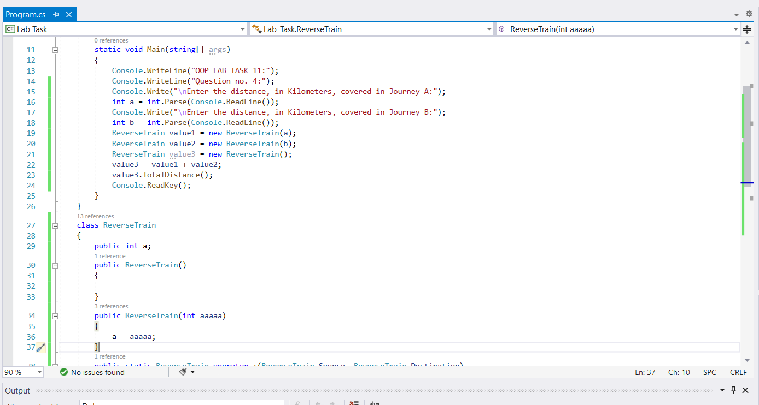

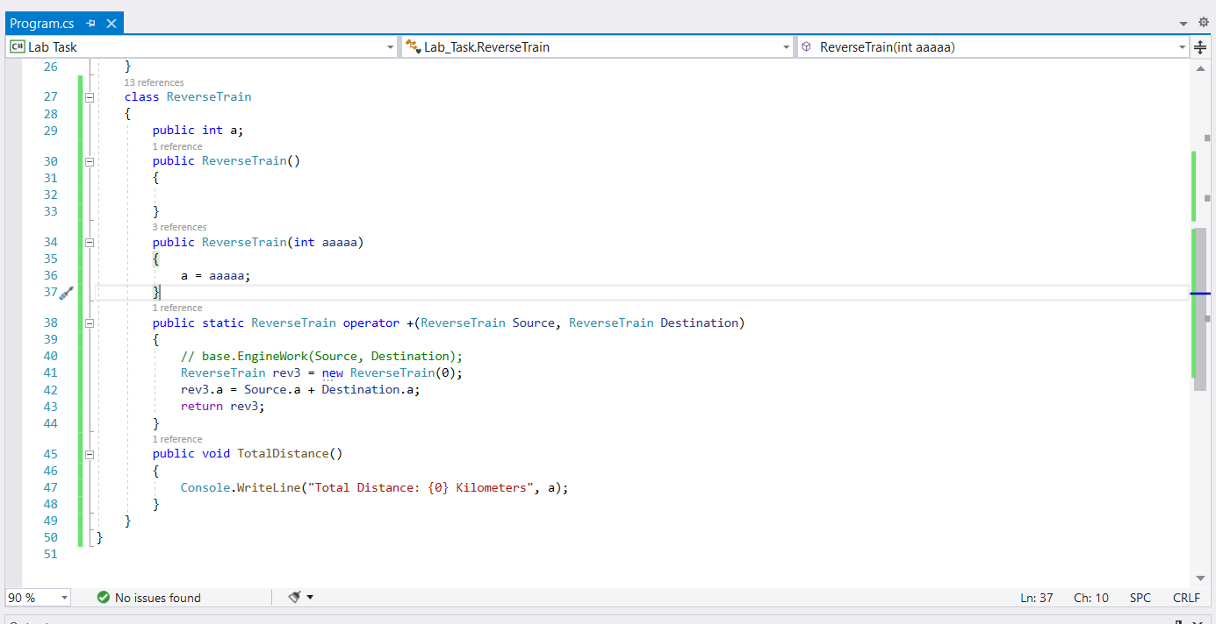

***Output:***

